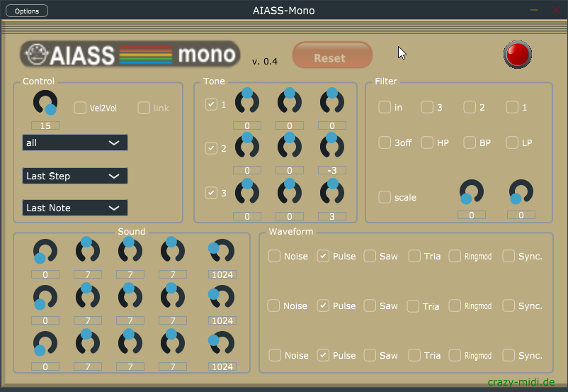
AIASS-Mono-VST
A VST for the SIDBlaster-USB
Programming and UI design by Andreas Schumm
Copyright © 2021
www.crazy-midi.de
English manual by help of Magnus Hansson, version 1.0
Index
Hardware installation III
SID-chip installation III
Voltage Jumper settings on the SIDBlaster hardware IV
Other jumpers on the hardware V
USB and audio connections V
General information VI
Software installation VII
AIASS-Mono-VST VIII
Master section: VIII
Oscillator and envelope section: IX
Oscillator Pitch section X
ADSR envelope and Pulse Width X
Waveforms and Noise XI
Filter section XII
Power LED XIII
Tips XIV
Links XIV
Thanks to XV

Hardware installation

SID-chip installation
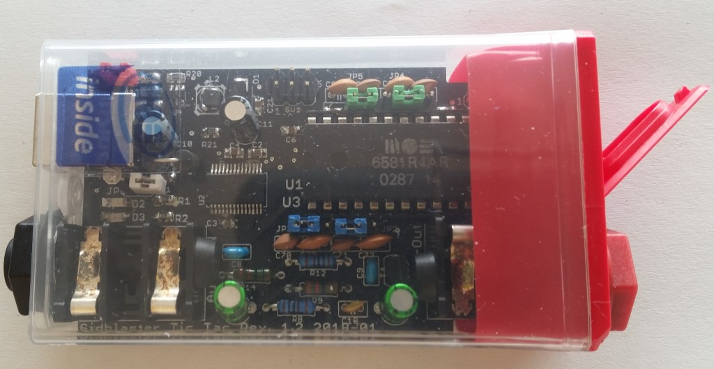
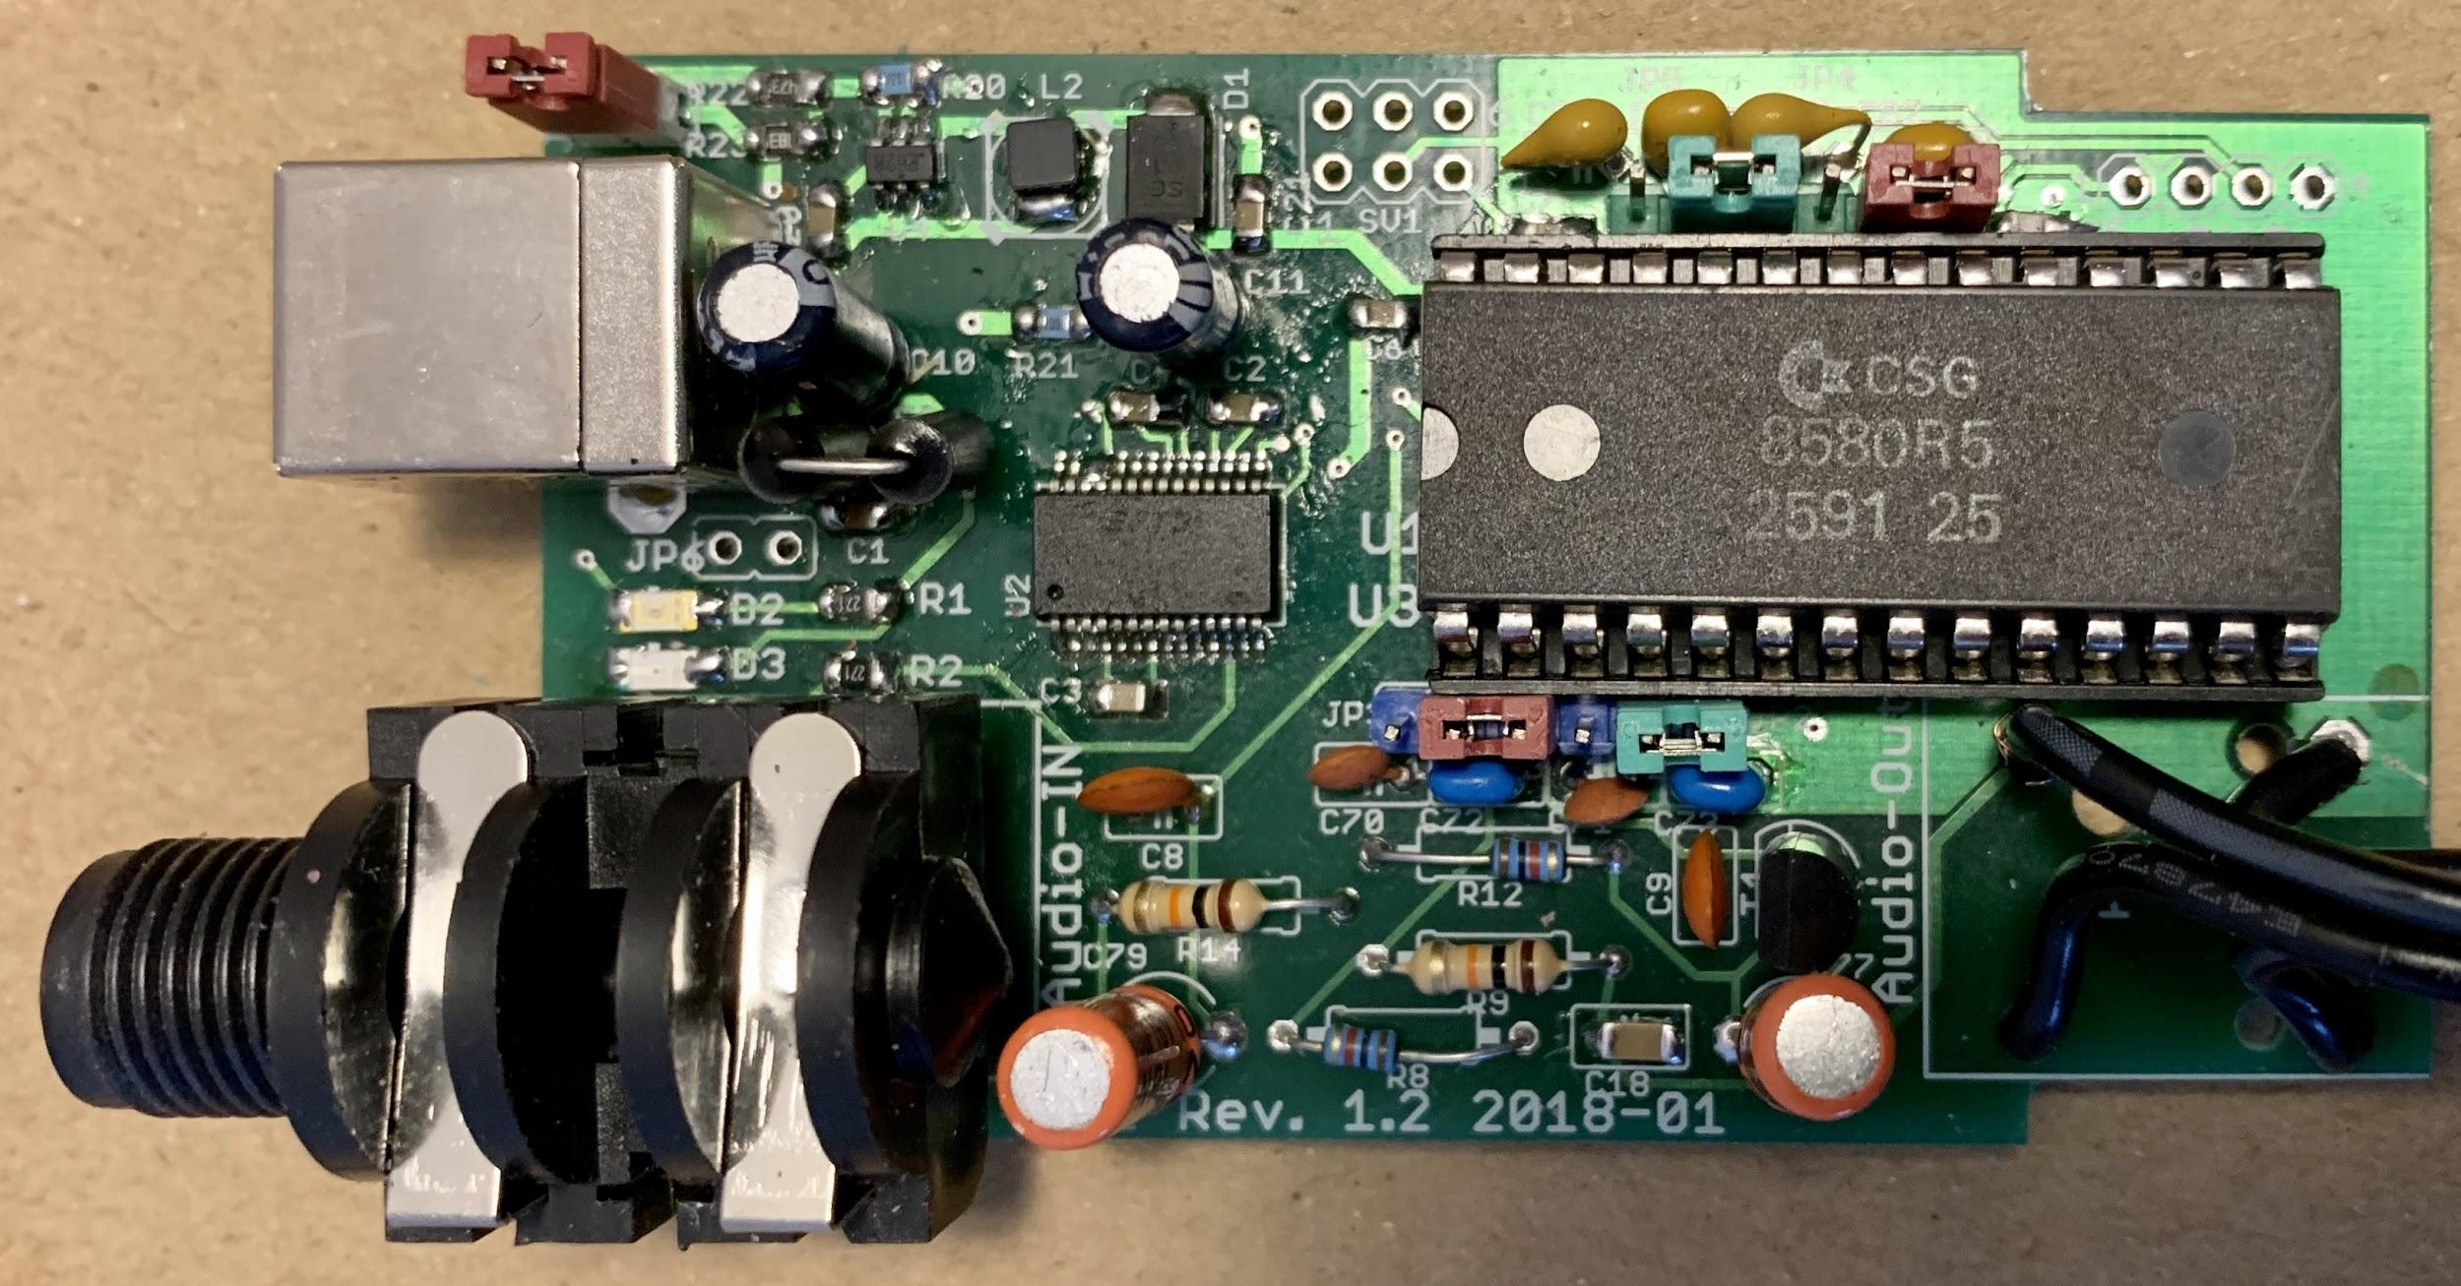SIDBlaster with an 8580 SID-chip correctly installed.

Voltage Jumper settings on the SIDBlaster hardware
For the 6581 SID-chip - J1 must be open (12V). Place all jumpers on the left side (pins 1-2).
For the 8580 SID-chip - J1 must be closed (9V). Place all jumpers on the right side (pins 2-3).
Warning! Double check the voltage settings on the SIDBlaster hardware. If you set them incorrectly, for example sending 12V into an 8580 SID-chip which runs at 9V, you will destroy the chip. If you have a multimeter, check the voltage at the SID chip socket to be sure.
Always use an anti static bracelet to avoid damaging the SID-chip and other electrical components when installing it in the SIDBlaster.

Other jumpers on the hardware
JP2 & JP3 (blue) are for switching the filter capacitors.
JP4 & JP5 (green) are for the optional paddle capacitors.
JP6 (White) From Rev. 1.2 and on. Experimental, connects USB shield to ground; you may try it to counteract interfering noise.
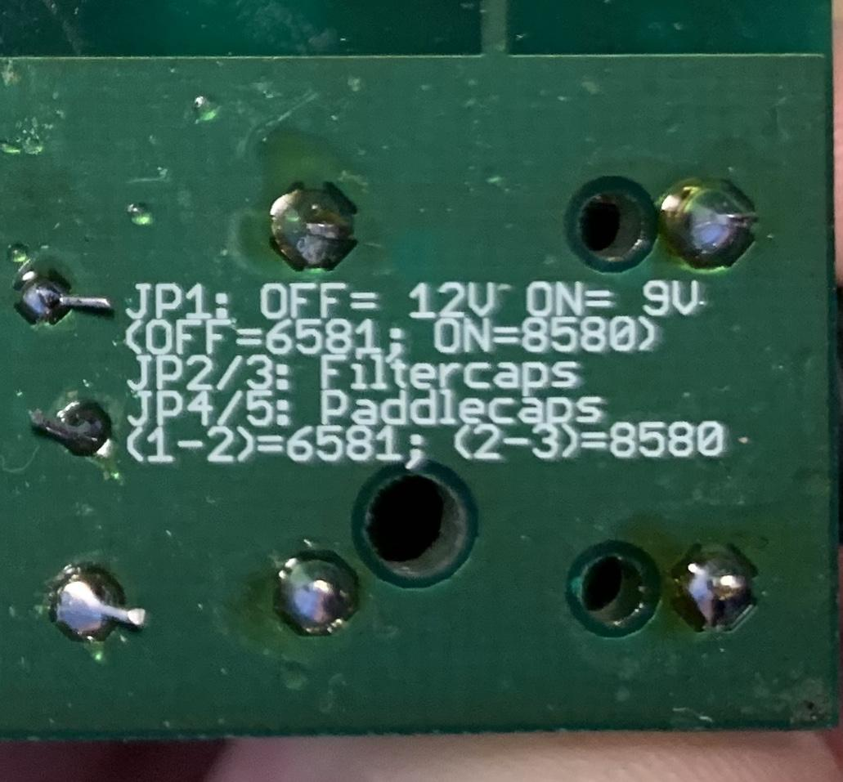Text on reverse side of SIDBlaster PCB with jumper settings.

USB and audio connections
Connect the SIDBlaster hardware to a USB port using a type A-B USB cable of good quality. It can also work with a good quality USB-hub.
The SIDBlaster needs to do a digital "handshake" the first time it is connected via USB. This requires an internet connection. The handshake will not work if your internet connection is set to “Metered Connection” in Windows. To solve this, temporarily disable “Metered Connection”, wait a moment for the SIDBlaster to do the handshake, and then re-enable “Metered Connection”.
Connect the audio output of the SIDBlaster to your mixer or audio interface using an unbalanced (mono) cable. The second audio jack on the SIDBlaster is an audio input and is also an unbalanced connection. If you are unsure which connector is which, the connectors are marked on the PCB. Be careful about what you connect to the input of the SID-chip. These chips are old and very sensitive to electrical spikes and too high voltages.

General information
Plug and play is not possible, the SIDBlaster must be plugged
in before starting Ableton Live
When you are not using the SIDBlaster it is recommended to unplug the USB-connection since this prolongs the life of the SID-chip.
Since a SID-chip produces heat, use a heatsink on the chip if possible and make sure there is sufficient ventilation.

Software installation
Download the AIASS devices, the “SID-object” folder with all its content and PDF-manual from:
https://github.com/gh0stless/AIASS-for-MAX4LIVE
Copy the SID-object folder and all its content to:
Documents/Max8/packages/
or
Documents/Max7/Packages/ (if you have an earlier version of MAX)
The SIDBlaster is recognised by Windows as a “USB Serial Converter”. It may be recognized as a COMx device with ports (in Device Manager). In this case, you can deactivate VCP in “Expanded”.
With older versions of Windows, installation of a driver by FTDI may be necessary, available at:
http://www.ftdichip.com/Drivers/D2XX.htm

AIASS-Mono-VST

Master section:
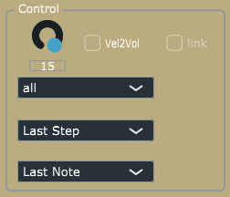
Volume = Master volume. To get the best possible signal to noise ratio, it is best to leave it a 15.
Vel2Vol = When activated velocity will control Master volume.
Reset = Double click resets AIASS to its default setting. Warning! All unsaved settings will be lost when pressing "Reset/Init".
Play Mode =
- Retrigger - Notes are retriggered every time a key is pressed, but if more than one key is held, the note will return to its previous pitch after the second key is released,
- Legato - Notes are played Legato, i.e. the pitch "glides" between notes.
- Last step - Notes are retriggered every time a key is pressed, and if more than one key is held the previous note will be cut off.
Note mode =
- Last Note priority prioritises the last Midi note when several notes are pressed.
- High Note priority prioritises the highest Midi note when several notes are pressed.

- Low Note priority prioritises the lowest Midi note when several notes are pressed.

Link = Links the controls for oscillator tuning, ADSR and Pulse Width, which is helpful when adjusting the sound for all oscillators at the same time. If unchecked, all controls are edited one by one.

Oscillator and envelope section:
There are 3 oscillators on a SID chip, each with its own ADSR envelope hardwired to the VCA (Voltage Controlled Amplifier), i.e. creating a volume envelope. The filter is not connected to an envelope on the SID chip by design.
However, there are ways around this as described in the tips section.

Oscillator Pitch section
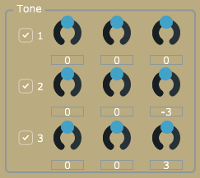
The oscillator pitch can be changed using the:
Oct = Changes the oscillator pitch up or down in one octave steps
Semi = Changes the oscillator pitch up or down in semitone steps
Cent = Fine tunes the oscillator pitch

ADSR envelope and Pulse Width
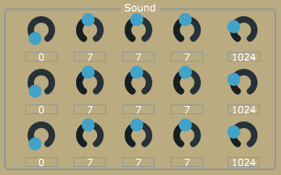
ADSR = As mentioned above, each oscillator has its own ADSR envelope. It allows control of the Attack, Decay, Sustain and Release time of each oscillator's VCA (Volume envelope).
Pulsew. = This controls the Pulse Width for each oscillator. It is particularly useful when using the Pulse waveform.

Waveforms and Noise
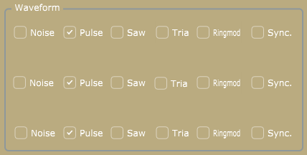
Each oscillator has three waveforms, Pulse, Saw and Triangle, plus Noise. Several waveforms can be selected at the same time. However, the noise can not be combined with the other waveforms.
Ringmod = Ring modulation
This effect is only audible when the Triangle wave is activated.

Ringmod.1 Activates the Ring Modulation on Voice 1.
The Oscillator must be set to Triangle Wave.
It is a ring modulation of voice 1 and voice 3.

Ringmod.2 Activates the Ring Modulation on Voice 2.
The Oscillator must be set to Triangle Wave.
It is a ring modulation of voice 2 and voice 1.

Ringmod.3 Activates the Ring Modulation on Voice 3.
The Oscillator must be set to Triangle Wave.
It is a ring modulation of voice 3 and voice 2.

Sync. = Synchronizes the Oscillators to each other.
Sync. 1 Activates the Oscillator Sync on Voice 1. This syncs Voice 1 with Voice 3. The frequency of Voice 3 must be lower than Voice 1 for it to have any audible effect.

Sync. 2 Activates the Oscillator Sync on Voice 2. This syncs Voice 2 with Voice 1. The frequency of Voice 1 must be lower than Voice 2 for it to have any audible effect.

Sync. 3 Activates the Oscillator Sync on Voice 3. This syncs Voice 3 with Voice 2. The frequency of Voice 2 must be lower than Voice 3 for it to have any audible effect

Filter section
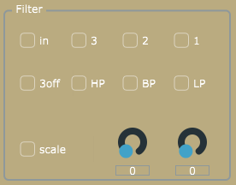
In = There is an option to activate the filter for the external input. This will raise the noise level since the input of a SID-chip is quite noisy by design. Actually, the SID-chip is pretty noisy, but that’s also part of the charm. As mentioned above, please be careful about what you connect to the input of the SID-chip. SID-chips are old and very sensitive to electrical spikes and too high voltages.
Filter activation buttons = The filter is activated for each oscillator separately (oscillator 1-3).
Scale button = There are two main types of SID-chip, the 6581-version and the newer 8580-version. The main difference is the filter. The 8580-version has an updated filter where the resonance control is more effective. The cutoff characteristics are also different between the two chips. The two modes of this button sets the cutoff scale for the 8580 and 6581 respectively. Try both scales, it might sound nice.
Filter types =
LP = Low Pass
BP = Band Pass
HP = High Pass
All filter types can be freely combined.
Freq. = Changes the filter Cutoff Frequency for all oscillators which have their filter activated.
Res. = Changes the Resonance amount for all oscillators which have their filter activated.

Power LED

If the Power LED flashes at a rate of 125ms, the SID-object has not been found.
If the Power LED flashes at a rate of 250ms, an error in the SID-object has been detected. This could mean that the .dll file is not found or that the computer can not find the SIDBlaster hardware.

Tips
- Add as many LFO’s as you want to SIDBlaster with Midi LFO’s.
- Add as many ADSR-envelopes as you want to SIDBlaster with Midi Envelopes.
- Lower the AIASS the Decay and Sustain settings if you get internal distortion. The SID-chip distorts quite easily, especially when playing all oscillators at the same time.

- Try an Arpeggiator with a fast tempo on the Mono version of AIASS to get classic Commodore C64 arpeggiated "chords".

- You can map a Midi controller to any AIASS parameter, for example: Mod Wheel to Cutoff Frequency.

Links
https://github.com/gh0stless/AIASS-for-MAX4LIVE
http://crazy-midi.de/
https://www.ableton.com/en/packs/max-live-essentials/

Thanks to
- Davey (The Phantom) for creating the SIDBlaster.
- Wilfred Bos for tips and helping.
- Stein Pedersen for assistance and the sidblaster.dll.
- Rico Frenzel for help and testing.
- Karl-Werner Riedel for his help with designing the TicTac hardware.
- Magnus Hansson for ideas, testing, presets and writing this nice manual.
- Borjana Konstantinowa for her patience with me.
-Andreas

